A Project Report

On

Memory-Book App

By

Atharva Gogawale (T190458524)

Tejal Khadke (T190458532)
Ajeet Lokhande (T190458540)

Under the guidance of

Dr. Bharati P. Vasgi


Department of Information Technology

Marathwada Mitra Mandal’s COE

SAVITRIBAI PHULE PUNE UNIVERSITY

2022-2023
Marathwada Mitra Mandal’s,

Department of Information Technology Marathwada Mitra Mandal College of Engineering , Pune-52

Date:

CERTIFICATE

This is to certify that,

Atharva Gogawale (TI22)

Tejal Khadke (TI30)

Ajeet Lokhande (TI38)

of class T.E IT have successfully completed their project work on “Memory-Book App’’ for LABORATORY PRACTICE-II (Web Application Development) at MARATHWADA MITRA MANDAL’S COLLEGE OF ENGINEERING in the partial fulfillment of the Graduate Degree course in T.E at the Department of Information Technology, in the academic Year 2022-2023 Semester – II as prescribed by the Savitribai Phule Pune University.

Dr. Bharati P. Vasgi

Guide

(Department of Information Technology)

ACKNOWLEDGEMENT

I feel great pleasure in expressing my deepest sense of gratitude and sincere thanks to my guide Dr. Bharati P. Vasgi for their valuable guidance during the Project work, without which it would have been a very difficult task. I have no words to express my sincere thanks for valuable guidance, extreme assistance and cooperation extended to all the Staff Members of my Department.

This acknowledgement would be incomplete without expressing my special thanks to Dr. Rupali M. Chopade, Head of the Department (Information Technology) for their support during the work.

I would also like to extend my heartfelt gratitude to my Dr. V. N. Gohokar who provided a lot of valuable support, mostly being behind the veils of college bureaucracy.

Last but not least I would like to thank all the Teaching, Non- Teaching staff members of my Department, my parents and my colleagues who helped me directly or indirectly for completing this Project successfully.

Name of Students

Atharva Gogawale (TI22)

Tejal Khadke (T130)

Ajeet Lokhande (TI38)
ABSTRACT

The Memory-Book App System is a user-friendly digital solution designed to streamline and enhance memory-book management/ to-do lists. With its functionalities to add, edit, view, and delete memory titles, individuals can efficiently organize and maintain their collections. The system allows individuals to easily add new memories, including important details such as title, tags and description.

Efficient memory notes management is crucial for memory operations, and the system provides a clear and organized view of all memory titles. Individuals can access a comprehensive list of the memory's memory titles, enabling them to browse, search, and retrieve specific memories based on various parameters like tags, description and date. This feature simplifies the process of locating memories and improves overall accessibility for memory-book users.

It also provides a simple and intuitive interface for editing memory titles, ensuring the memory's collection remains up to date. Individuals can access a comprehensive list of all memory titles, facilitating seamless browsing, searching, edit or delete. Moreover, the system allows for the removal of memory titles that are no longer relevant or available. By leveraging the Memory App System, individuals can improve accessibility, accuracy, and efficiency in managing their memory titles, providing an enhanced experience for users.

INDEX

Sr. No | Contents | Page nos.
1 | Introduction to the Memory-Book App | 6
1.1 | Problem Statement | 6
1.2 | Scope | 7
2 | Specific Requirements | 8
2.1 | Hardware Requirements | 8
2.2 | Software Requirements | 9
3 | MERN Stack | 10
4 | Features of the Memory-Book App | 13
5 | Conclusion | 23
 | References | 24

CHAPTER 1

INTRODUCTION TO THE MEMORY-BOOK APP

1.1 Problem Statement

The primary objective of this project is to empower individuals with a tool that simplifies the process of adding new memories to the memory collection. Individuals can effortlessly enter vital information such as memory title, tags, description. This feature significantly enhances the efficiency of cataloging new additions to the memory's collection. It is crucial for individuals to update memory titles regularly. The Memory App System allows for easy editing of memory titles, facilitating the incorporation of corrections, updates, or revisions. Individuals can swiftly modify existing memory titles, ensuring the accuracy and relevance of the memory's collection.

The system also offers a comprehensive view of all memory titles, enabling individuals to efficiently browse, search, and retrieve specific memories. This feature significantly improves accessibility and enhances the overall user experience. With a few simple clicks, individuals can quickly locate and provide valuable resources to memory users. Additionally, the Memory-App System supports the removal of memory titles that are no longer required or available. By providing straightforward functionality to delete memory book, the system ensures the memory's collection remains current and clutter-free.

Through this project, we strive to empower users with a state-of-the-art digital solution that revolutionizes memory or to-do lists management aligning with the evolving needs of users and ensuring a seamless experience for users.
1.2 Scope:

The Memory-book App System project aims to develop a user-friendly web application. It will focus on functionalities such as adding, editing, viewing, and deleting memory titles. The system will ensure accuracy and consistency by validating input data and maintaining data integrity.

Key Features:

- Adding new memories with details like title, tags, description.

- Editing memory-book titles to incorporate updates, revisions, or corrections.

- Viewing a comprehensive list of all memory-book titles, enabling easy browsing, searching, and filtering.

- Deleting memory-book titles that are no longer required or available to maintain an accurate collection.

Technical Aspects:

- Development of a web-based application using modern web technologies.

- Scalable, secure, and responsive design compatible with various devices and browsers.

- Thorough testing to ensure functionality, performance, and reliability.

Limitations:

The Memory-book App System will focus solely on management of memory dairy and user login.

Overall, the Memory-book App System project aims to enhance memory management by providing a user-friendly interface and essential functionalities. It will ensure accuracy, accessibility, and efficiency in maintaining the memory's collection, benefiting the users in their daily lives.
CHAPTER 2

SPECIFIC REQUIREMENTS

2.1 HARDWARE REQUIREMENTS

RAM: 4GB

- Allows for smooth running of our Memory-book App application PROCESSOR: Intel i5 processor

- i5 processors are powerful and they allow us to multitask at high processing speeds HARD DISK: Minimum 256 GB storage

- Minimum of 256GB HDD storage will ensure that our Memory-book App application has all the space that it needs
2.2 SOFTWARE REQUIREMENTS

OS: Windows 7 or above

- OS of Windows 7 or above will ensure that all the libraries and dependencies, as well as the development environment of our application will run smoothly

DATABASE: MongoDB Atlas

- MongoDB Atlas is an integrated suite of data services centered around a cloud database designed to accelerate and simplify how you build with data.

IDE: VS Code

- Visual Studio Code is a code editor redefined and optimized for building and debugging modern web and cloud applications.

WEB SERVER: Express.js

- Express is a minimal and flexible Node.js web application framework that provides a robust set of features for web and mobile applications.

LIBRARIES: React.js and Node.js

- React.js is a free and open-source front-end JavaScript memory for building user interfaces based on components.
- Node.js is a back-end JavaScript runtime environment, runs on the V8 JavaScript Engine, and executes JavaScript code outside a web browser.
CHAPTER 3

MERN STACK

The MERN stack is a popular and powerful combination of technologies used in web development. Composed of four main components - MongoDB, Express.js, React.js, and Node.js - the MERN stack enables developers to create robust, scalable, and efficient web applications. Each component plays a unique role in the stack, contributing to the overall success of the development process. In this report, we will delve into each component of the MERN stack, highlighting their key features and benefits.

MongoDB: Flexible and Scalable Database Solution

MongoDB, a document-oriented NoSQL database, serves as the foundation of the MERN stack. It offers a flexible and scalable approach to data storage, allowing developers to handle complex data structures with ease. MongoDB stores data in JSON-like documents, offering a seamless integration with the JavaScript-based technologies used in the stack.

The advantages of MongoDB lie in its ability to handle large amounts of data, its support for horizontal scaling, and its schema-less nature. By utilizing MongoDB in the MERN stack, developers can efficiently manage data, ensure high performance, and easily adapt to evolving business requirements. Additionally, MongoDB's powerful querying capabilities and built-in replication and sharding features make it an excellent choice for building data-intensive applications.

Express.js: Efficient and Flexible Server-Side Framework

Express.js, a minimalist and flexible web application framework for Node.js, acts as the server-side component in the MERN stack. Express.js simplifies the process of building robust

web applications by providing a set of powerful features and middleware. Its lightweight nature allows for faster development and reduced overhead, making it a favored choice among developers.

Express.js facilitates the creation of APIs and handles server-side routing, making it easier to define routes, handle HTTP requests, and implement authentication and validation mechanisms. Its modular architecture enables developers to add functionalities through various middleware and extensions, fostering code reusability and maintainability. Express.js seamlessly integrates with other components of the MERN stack, enabling smooth data flow and enhanced performance.

React.js: Interactive and Reusable User Interfaces

React.js, a JavaScript memory developed by Face memory, takes care of the client-side rendering and user interface (UI) of MERN stack applications. With its component-based architecture and declarative syntax, React.js enables developers to build interactive and reusable UI components. This approach enhances the development process by promoting code reusability, modularity, and efficiency.

React.js offers a virtual DOM (Document Object Model) that optimizes UI rendering, resulting in faster and smoother user experiences. Its unidirectional data flow ensures predictable and manageable state management, enhancing application performance. React.js also provides a vast ecosystem of third-party libraries and tools, simplifying common UI tasks and allowing developers to focus on building rich, responsive, and intuitive interfaces.
Node.js: Scalable and Event-Driven JavaScript Runtime

Node.js, a server-side JavaScript runtime, completes the MERN stack by acting as the runtime environment for server-side code execution. Node.js allows developers to write server-side applications using JavaScript, unifying the language used throughout the entire stack. It offers a non-blocking, event-driven architecture that enables high concurrency and scalability.

Node.js leverages a single-threaded event loop, which allows it to handle a large number of concurrent connections efficiently. This makes it suitable for building real-time applications, chat applications, streaming servers, and more. Its extensive package ecosystem, provided by npm (Node Package Manager), empowers developers with a wealth of ready-to-use modules, simplifying development and reducing time to market.
CHAPTER 4

FEATURES OF THE MEMORY-BOOKAPP

There are the main features of the Memory application:

  - Registration Feature:

The recently added registration feature in the Memory-book App System provides users with a seamless process to create their accounts. With this functionality, users can easily register by providing their relevant information such as name, email address, and password. The system ensures data security by securely storing user credentials and employing industry-standard encryption techniques. The registration feature enhances user engagement and allows users to personalize their experience within the Memory-book App System.

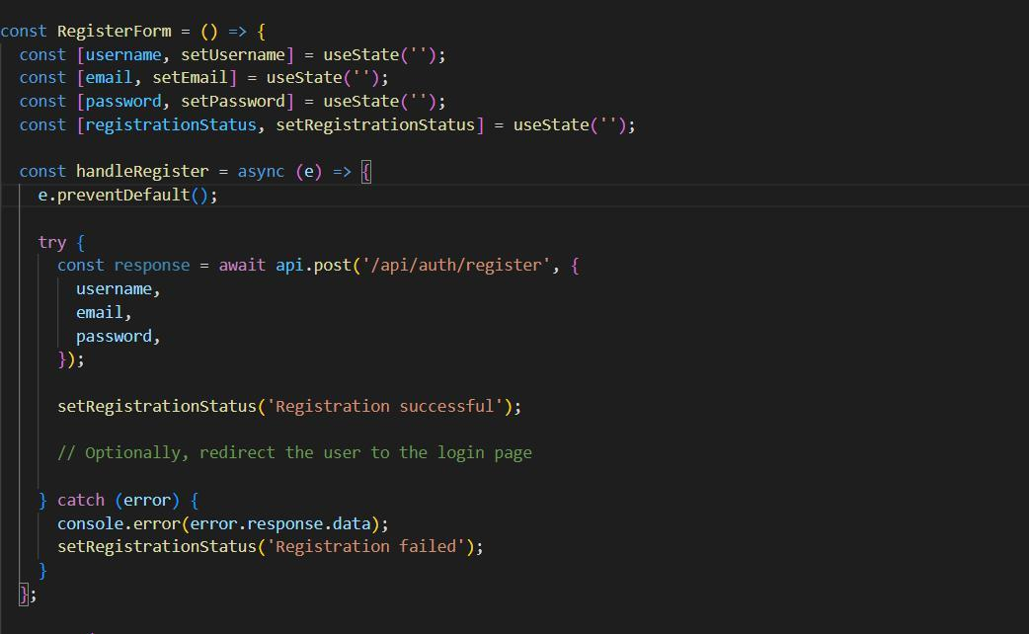
Code:
Fig 1

Output:

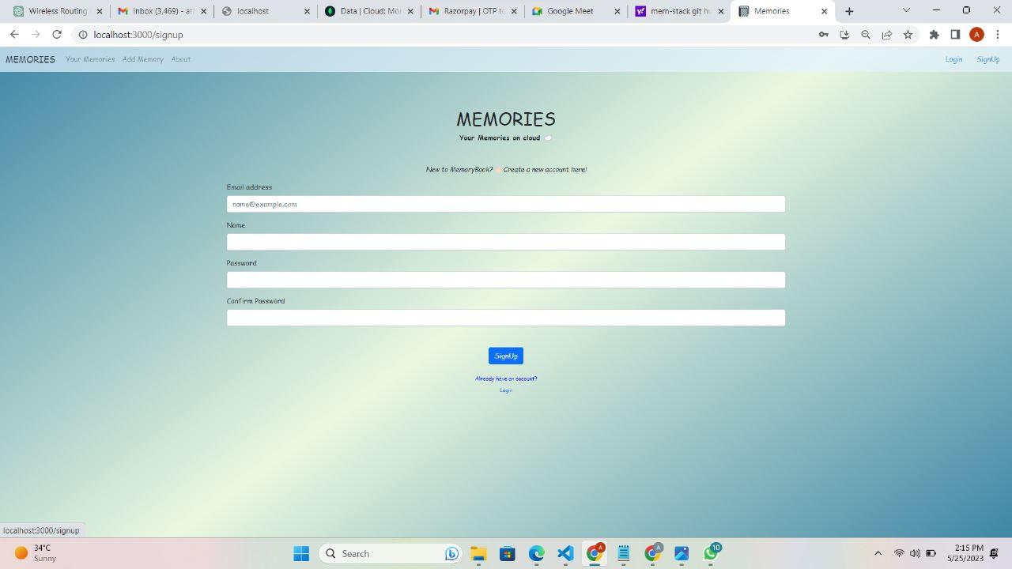

Fig 2

  - Login Feature:

The login feature is an essential component of the Memory-book App System, granting registered users secure access to their accounts. Once registered, users can easily log in using their unique credentials, typically their email address and password. This feature provides a secure and personalized environment for users to access the system's functionalities. By validating user credentials, the login feature ensures that only authorized users can view and interact with the memories and other resources within the Memory-book App System.

Code:
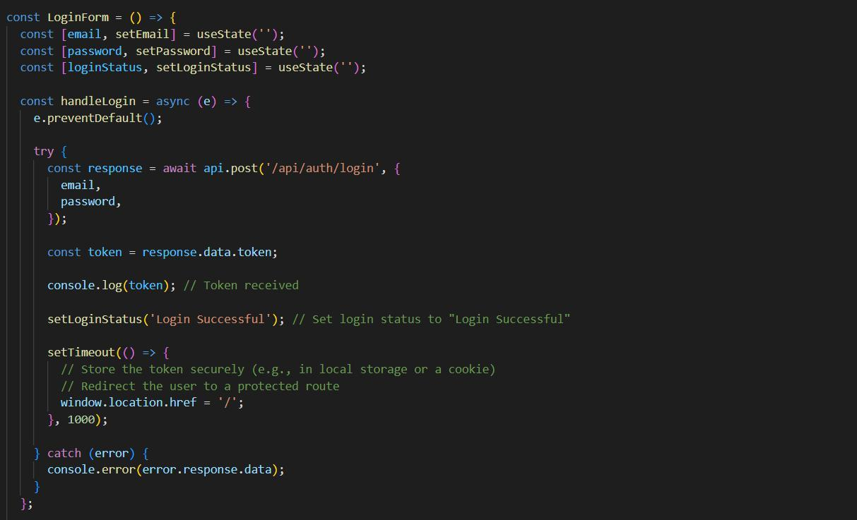

Fig 3
Output:

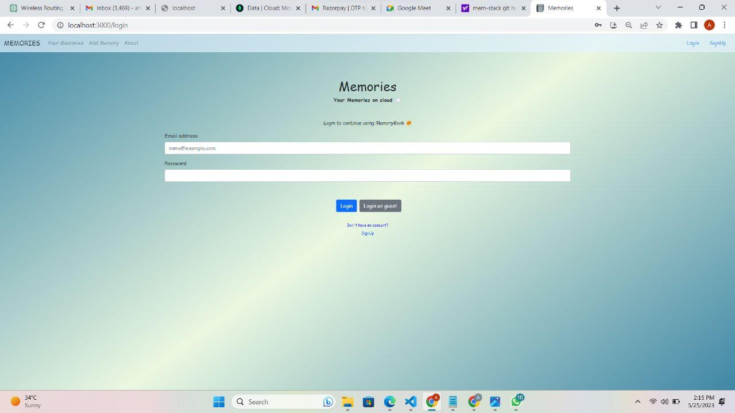

Fig 4
  - Search Feature:

The addition of a search feature greatly enhances the usability and accessibility of the Memory-book App System. Users can now conveniently search for specific memories by title using a search bar or dedicated search functionality. The search feature utilizes intelligent algorithms to quickly retrieve relevant results based on user input, providing an efficient and accurate search experience. By enabling users to find memories based on titles, the search feature saves time and enhances the overall user experience within the Memory-book App System.
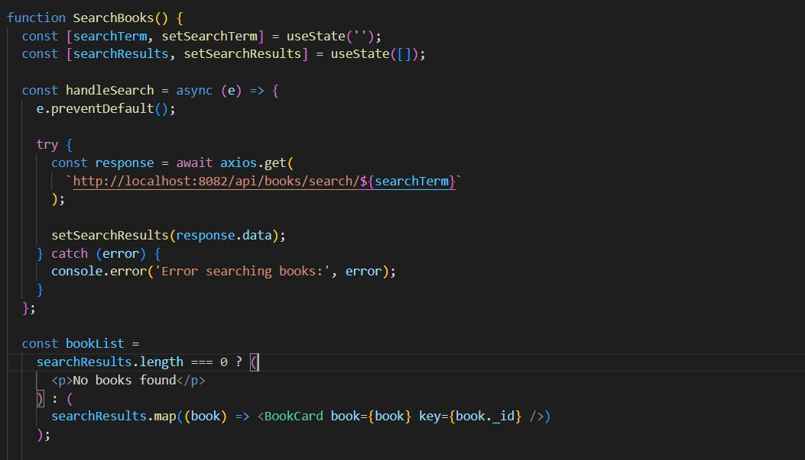

Fig 5
Output:

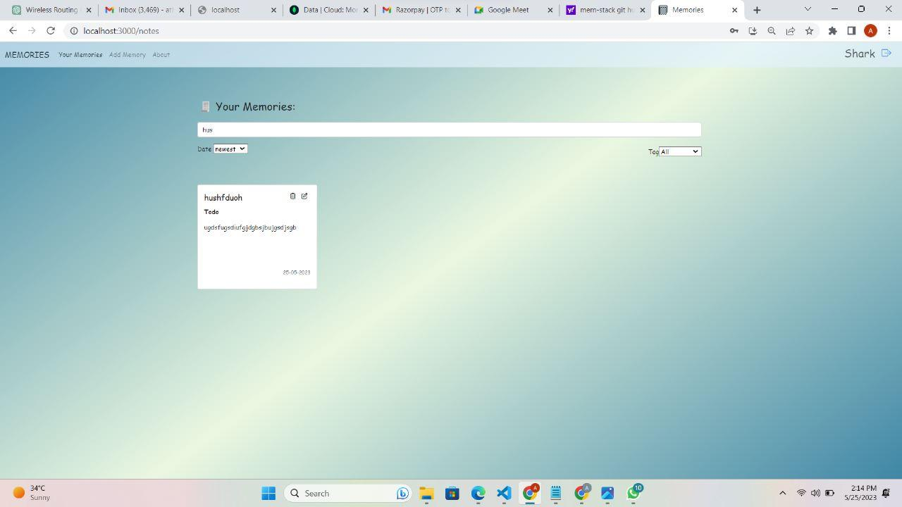

Fig 6

  - Add Memory Feature:

The use of the add memory feature presents users with an organized and comprehensive view of available memories within the Memory-book App System. This feature displays the memories in a user-friendly list format, providing essential details such as title, tag and description. The users can add the new memories based on details such as title, tag and description.
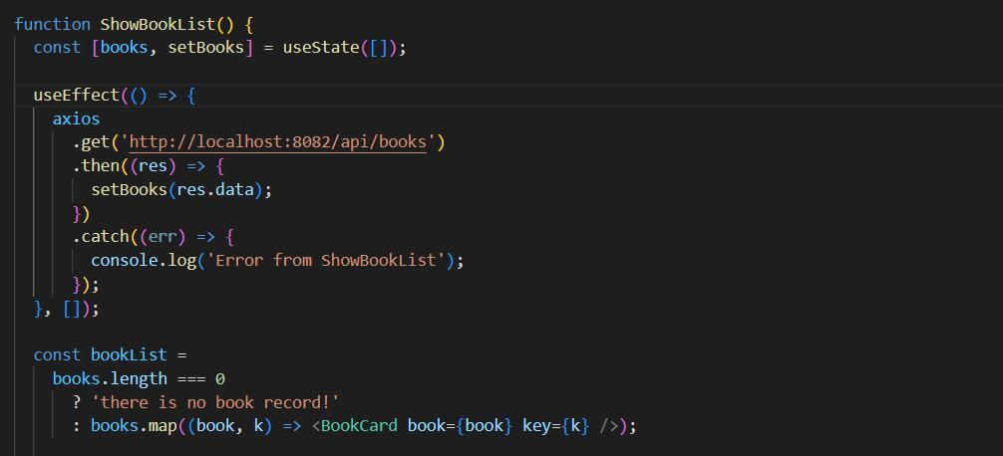

Fig 7
Output:

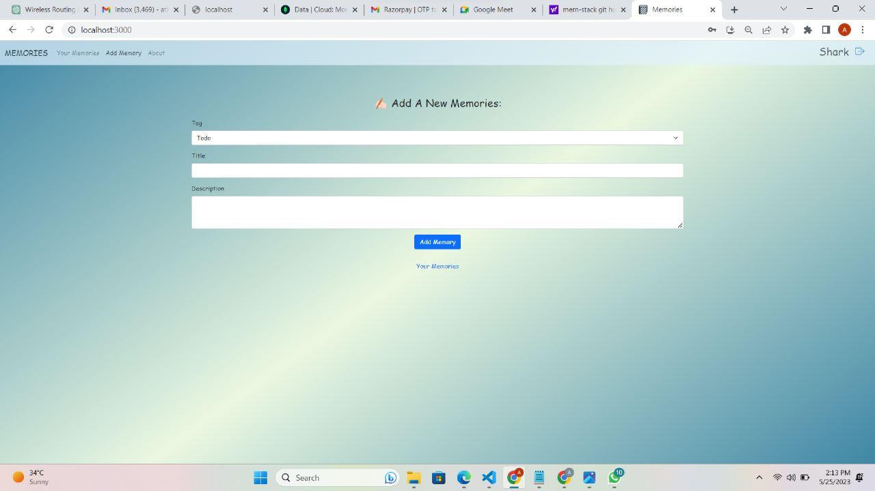

Fig 8

  - Edit Memory Feature:

The newly added edit memory feature grants exclusive access to users of the Memory-book App System, empowering them to modify memory details as needed. Users can access the editing functionality, allowing them to update information such as memory titles, tags and description. This feature ensures that the memory's collection remains up to date, reflecting changes, revisions, or corrections.
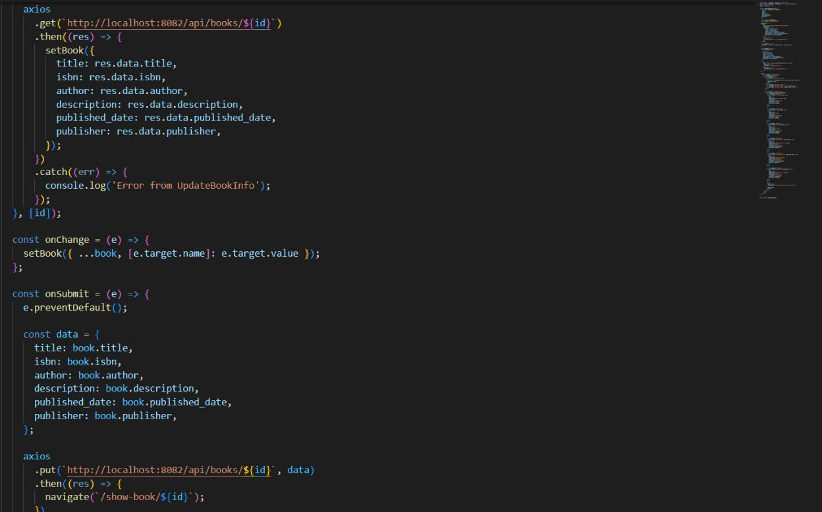

Fig 9
Output:

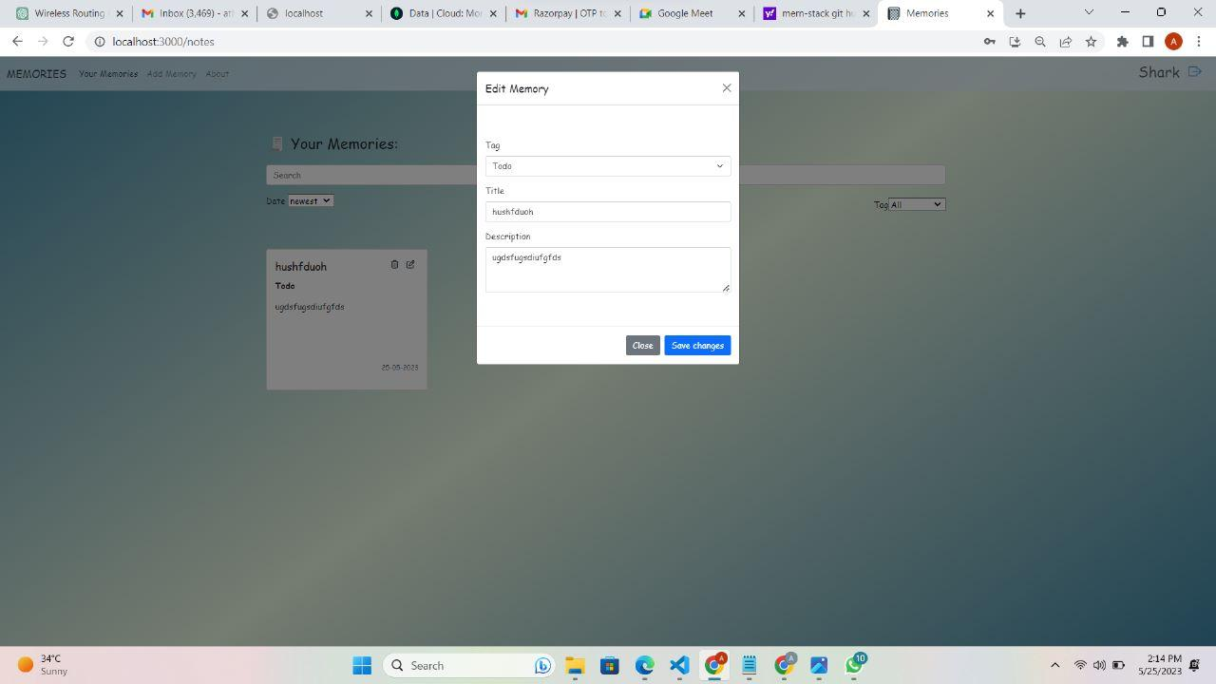

Fig 10
CHAPTER 5

CONCLUSION

The Memory-book App System project has successfully developed a user-friendly web application that revolutionizes managing memory-book and documenting life. By incorporating functionalities such as adding, editing, viewing, and deleting memory titles, the system empowers individuals with efficient tools to organize and maintain their collections.

Through the implementation of modern web technologies, the Memory App System ensures scalability, security, and responsiveness. Leveraging the power of the MERN (MongoDB, Express.js, React.js, and Node.js) stack, the application provides a seamless experience for users in managing memory titles.

Overall, the successful implementation of the Memory-book App System has significantly enhanced memory or daily notes management, improving accuracy, accessibility, and efficiency. The project has demonstrated the power of the MERN stack in developing a robust and user-friendly web application, revolutionizing the way we organize and maintain our daily to-do lists.
CHAPTER 6

REFERENCES

- https://www.mongodb.com/docs/

- https://react.dev/blog/2023/03/

- https://nodejs.org/en/docs

- https://expressjs.com/en/5x/api.html

- Eloquent Javascript, by Marijn Haverbeke

